
EMPLOYMENT APPLICATION REVIEW SYSTEM (EARS)
D2 · Requirements and Specifications
Software Engineering — COSC 3506
Version 1.0 — Approved
Prepared by Chisom Ugochukwu & Yinka Akingbaso
Algoma University — July 29, 2026

Contents

1. Functional Requirements 3
2. Non-Functional Requirements 4
3. User Stories and Acceptance Criteria 5
4. Requirements Traceability Matrix 6

1. Functional Requirements
Fifteen functional requirements were identified through user story mapping, stakeholder interview simulation, and use-case analysis. Each requirement is stated in shall-form and traced to a design element and a test case in Section 4.
ID | Requirement | Description
FR-01 | User registration | The system shall allow new users to register with full name, email, password, and role (Applicant or Reviewer).
FR-02 | User authentication | The system shall authenticate users via email and password, create a server-side session, and redirect to role-appropriate dashboards.
FR-03 | Session management | The system shall automatically terminate user sessions after 30 minutes of inactivity.
FR-04 | Role-based access control | The system shall restrict page access by role: applicants cannot reach reviewer or admin pages, and reviewers cannot reach admin functions.
FR-05 | Job posting creation | The system shall allow administrators to create job postings with title, department, description, and requirements.
FR-06 | Job status management | The system shall allow administrators to open or close job postings; closed postings shall not appear to applicants.
FR-07 | Job browsing | The system shall display all open job postings to applicants with title, department, and description.
FR-08 | Application submission | The system shall allow applicants to submit applications including a cover letter and resume upload (PDF/DOC/DOCX, max 5 MB).
FR-09 | Duplicate prevention | The system shall prevent applicants from applying to the same job posting more than once.
FR-10 | Status tracking | The system shall display application status (Pending, Under Review, Interview, Accepted, Rejected) to applicants in real time.
FR-11 | Review dashboard | The system shall provide reviewers with a centralized dashboard listing all applications, with filtering and search.
FR-12 | Candidate evaluation | The system shall allow reviewers to score applicants on Technical Skills, Communication, Experience Match, and Culture Fit (1–5 each).
FR-13 | Evaluation calculation | The system shall automatically calculate the average score across the four evaluation criteria.
FR-14 | Interview scheduling | The system shall allow reviewers to schedule interviews of four types: Phone Screen (30 min), Technical (60 min), Final Round (90 min), and Panel (120 min).
FR-15 | Interview notification | The system shall display scheduled interviews to both applicants and reviewers with date, time, type, and location.

2. Non-Functional Requirements
ID | Category | Requirement
NFR-01 | Performance | The system shall load dashboard data within 2 seconds for up to 500 records.
NFR-02 | Security | Passwords shall be hashed using bcrypt with at least 10 salt rounds; all authenticated endpoints shall verify session validity.
NFR-03 | Usability | The UI shall be responsive across desktop (1920 px), tablet (768 px), and mobile (375 px) viewports.
NFR-04 | Reliability | The system shall maintain 99% uptime during business hours with automatic session recovery.
NFR-05 | Scalability | The database schema shall support up to 10,000 users and 50,000 applications without performance degradation.
NFR-06 | Maintainability | Code shall follow the MVC pattern with modular separation of concerns and comprehensive inline documentation.

3. User Stories and Acceptance Criteria
Requirements were elicited as user stories in the form "As a [role], I want [goal], so that [value]." Nine stories were defined across the three roles; Table 3 summarizes them.
ID | Role | Story
US 1.1 | Applicant | As an applicant, I want to register with my name, email, and password, so that I can access the system and apply for jobs.
US 1.2 | Applicant | As an applicant, I want to browse open job postings and apply with a cover letter and resume, so that I can compete for positions.
US 1.3 | Applicant | As an applicant, I want to track my application status in real time, so that I always know where I stand.
US 2.1 | Reviewer | As a reviewer, I want a centralized list of all applications, so that I can manage my review workload.
US 2.2 | Reviewer | As a reviewer, I want to score candidates against a standard rubric, so that evaluations are consistent and fair.
US 2.3 | Reviewer | As a reviewer, I want to schedule interviews from the dashboard, so that promising candidates move forward quickly.
US 3.1 | Administrator | As an administrator, I want to create and manage job postings, so that openings are accurately advertised.
US 3.2 | Administrator | As an administrator, I want to open and close postings, so that applicants only see active positions.
US 3.3 | Administrator | As an administrator, I want system statistics at a glance, so that I can monitor hiring activity.
Every story carries acceptance criteria in Given–When–Then form. The criteria for US 1.1 illustrate the convention used throughout:
- Given a visitor is on the registration page with a unique email address,
- When they submit a valid full name, email, password, and role,
- Then the system creates the account, hashes the password, and redirects them to the login page with a confirmation message.
The system-level actors and use cases that emerge from these stories are summarized in Figure 1.
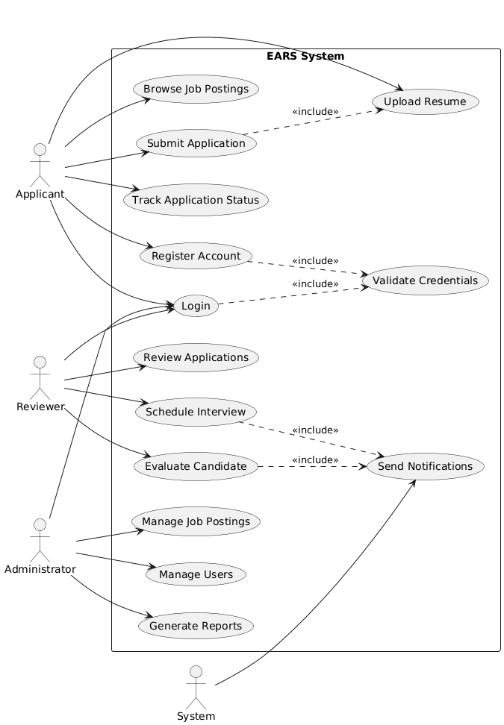
Figure 1: EARS use-case diagram — three actors, twelve use cases

4. Requirements Traceability Matrix
Each requirement is traced forward to the design element that implements it and the test case that verifies it. Nothing was designed or tested that was not required.
Requirement | Design Element | Test Case
FR-01 | User class, Register API | TC-AUTH-01
FR-02 | Session middleware, Login API | TC-AUTH-02
FR-03 | express-session maxAge | TC-AUTH-03
FR-04 | requireRole middleware | TC-SEC-01
FR-05 | Job class, POST /api/jobs | TC-JOB-01
FR-06 | Job status field, PUT /api/jobs | TC-JOB-02
FR-07 | Job list component | TC-JOB-03
FR-08 | Application form, multer upload | TC-APP-01
FR-09 | UNIQUE constraint (applicant_id, job_id) | TC-APP-02
FR-10 | Status badge component | TC-APP-03
FR-11 | Applications table component | TC-REV-01
FR-12 | Evaluation form, Evaluation class | TC-REV-02
FR-13 | Average calculation in API | TC-REV-03
FR-14 | Interview modal, Interview class | TC-INT-01
NFR-02 | bcrypt hashing, session config | TC-SEC-02

